**DAY 5 LAB PROGRAMS**

QUE

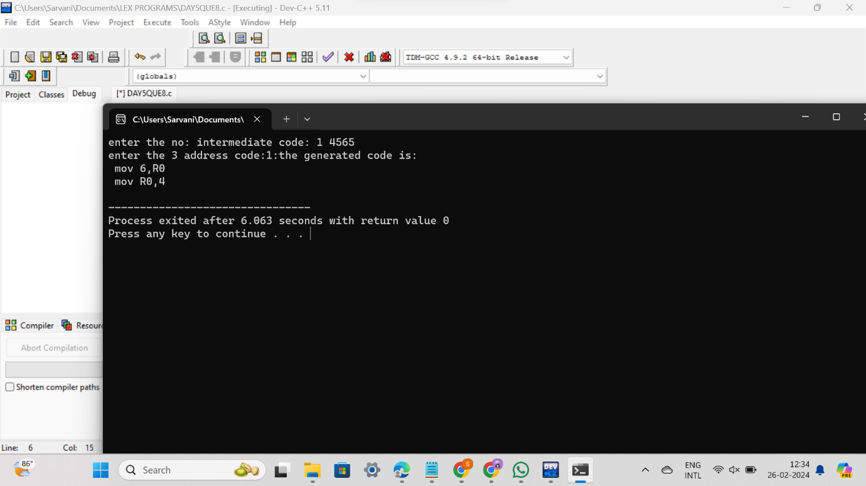

#include<stdio.h>

#include<conio.h>

#include<string.h>

int main()

{

int n,i,j;

char a[50][50];

printf("enter the no: intermediate code:");

scanf("%d",&n);

for(i=0;i<n;i++)

{

printf("enter the 3 address code:%d:",i+1);

for(j=0;j<6;j++)

{

scanf("%c",&a[i][j]);

}

}

printf("the generated code is:");

for(i=0;i<n;i++)

{

printf("\n mov %c,R%d",a[i][3],i);

if(a[i][4]=='-')

{

printf("\n sub %c,R%d",a[i][5],i);

}

if(a[i][4]=='+')

{

printf("\n add %c,R%d",a[i][5],i);

}

if(a[i][4]=='*')

{

printf("\n mul %c,R%d",a[i][5],i);

}

if(a[i][4]=='/')

{

printf("\n div %c,R%d",a[i][5],i);

}

printf("\n mov R%d,%c",i,a[i][1]);

printf("\n");

}

return 0;

}

Que 7

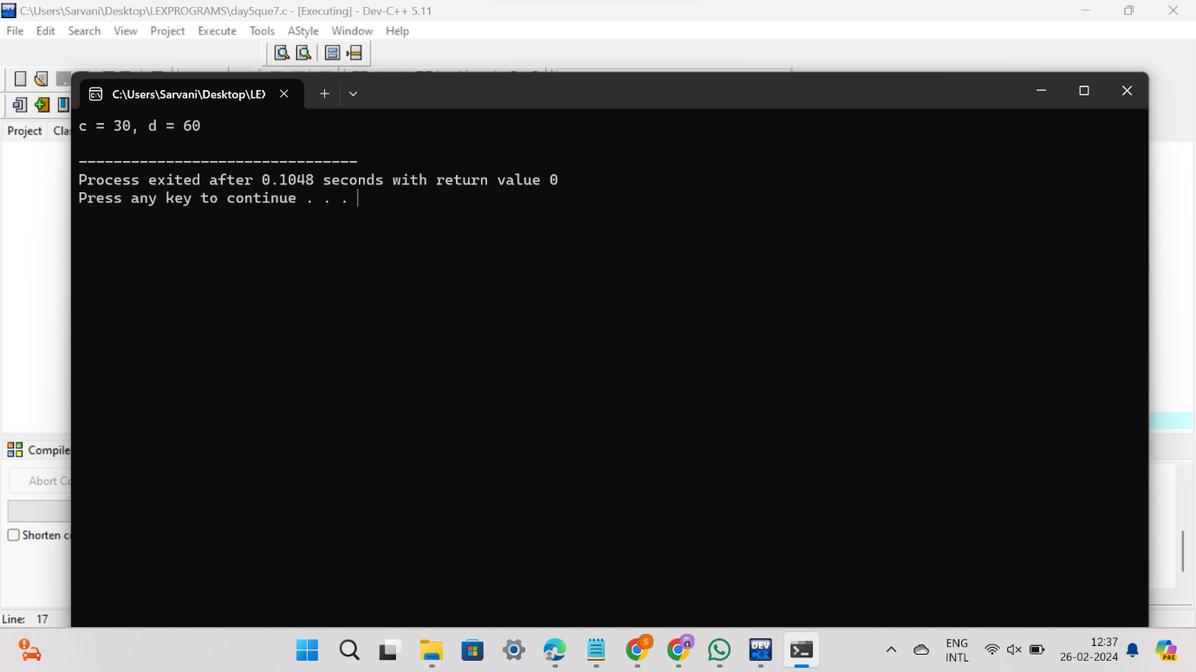

#include <stdio.h>

int main() {

int a = 10;

int b = 20;

int c = a + b;

int d = a + b * 2;

// Common subexpression elimination

int temp = a + b;

c = temp;

d = temp * 2;

printf("c = %d, d = %d\n", c, d);

return 0;

}

Que 6

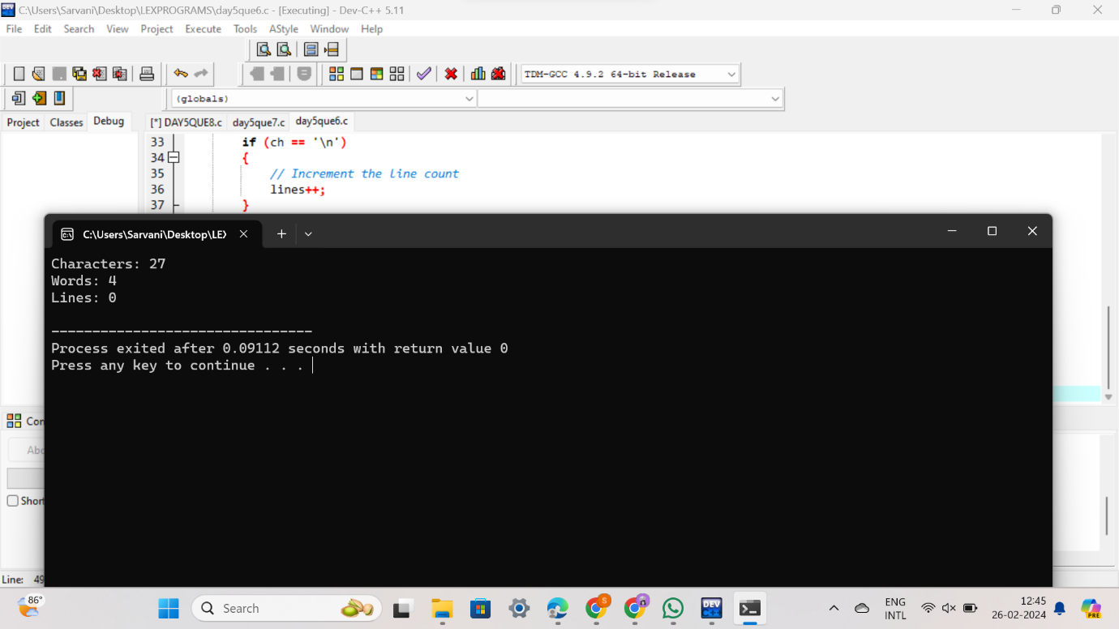

#include <stdio.h>

#include <stdlib.h>

int main()

{

int characters = 0, words = 0, lines = 0;

char ch;

// Open the file in read mode

FILE *fp = fopen("file.txt", "r");

// Check if the file exists

if (fp == NULL)

{

printf("Error: Could not open file\n");

exit(1);

}

// Read the file character by character

while ((ch = fgetc(fp)) != EOF)

{

// Increment the character count

characters++;

// Check if the character is a space or a newline

if (ch == ' ' || ch == '\n')

{

// Increment the word count

words++;

}

// Check if the character is a newline

if (ch == '\n')

{

// Increment the line count

lines++;

}

}

// Close the file

fclose(fp);

// Print the results

printf("Characters: %d\n", characters);

printf("Words: %d\n", words);

printf("Lines: %d\n", lines);

return 0;

}

Que 5

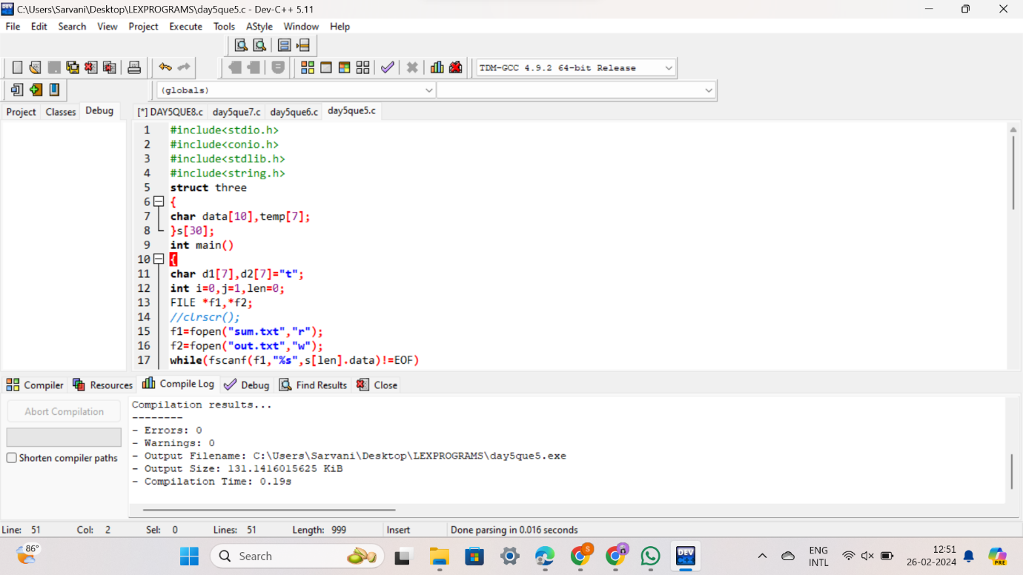

#include<stdio.h>

#include<conio.h>

#include<stdlib.h>

#include<string.h>

struct three

{

char data[10],temp[7];

}s[30];

int main()

{

char d1[7],d2[7]="t";

int i=0,j=1,len=0;

FILE *f1,*f2;

//clrscr();

f1=fopen("sum.txt","r");

f2=fopen("out.txt","w");

while(fscanf(f1,"%s",s[len].data)!=EOF)

len++;

itoa(j,d1,7);

strcat(d2,d1);

strcpy(s[j].temp,d2);

strcpy(d1,"");

strcpy(d2,"t");

if(!strcmp(s[3].data,"+"))

{

fprintf(f2,"%s=%s+%s",s[j].temp,s[i+2].data,s[i+4].data);

j++;

}

else if(!strcmp(s[3].data,"-"))

{

fprintf(f2,"%s=%s-%s",s[j].temp,s[i+2].data,s[i+4].data);

j++;

}

for(i=4;i<len-2;i+=2)

{

itoa(j,d1,7);

strcat(d2,d1);

strcpy(s[j].temp,d2);

if(!strcmp(s[i+1].data,"+"))

fprintf(f2,"\n%s=%s+%s",s[j].temp,s[j-1].temp,s[i+2].data);

else if(!strcmp(s[i+1].data,"-"))

fprintf(f2,"\n%s=%s-%s",s[j].temp,s[j-1].temp,s[i+2].data);

strcpy(d1,"");

strcpy(d2,"t");

j++;

}

fprintf(f2,"\n%s=%s",s[0].data,s[j-1].temp);

fclose(f1);

fclose(f2);

getch();

}

QUE 4

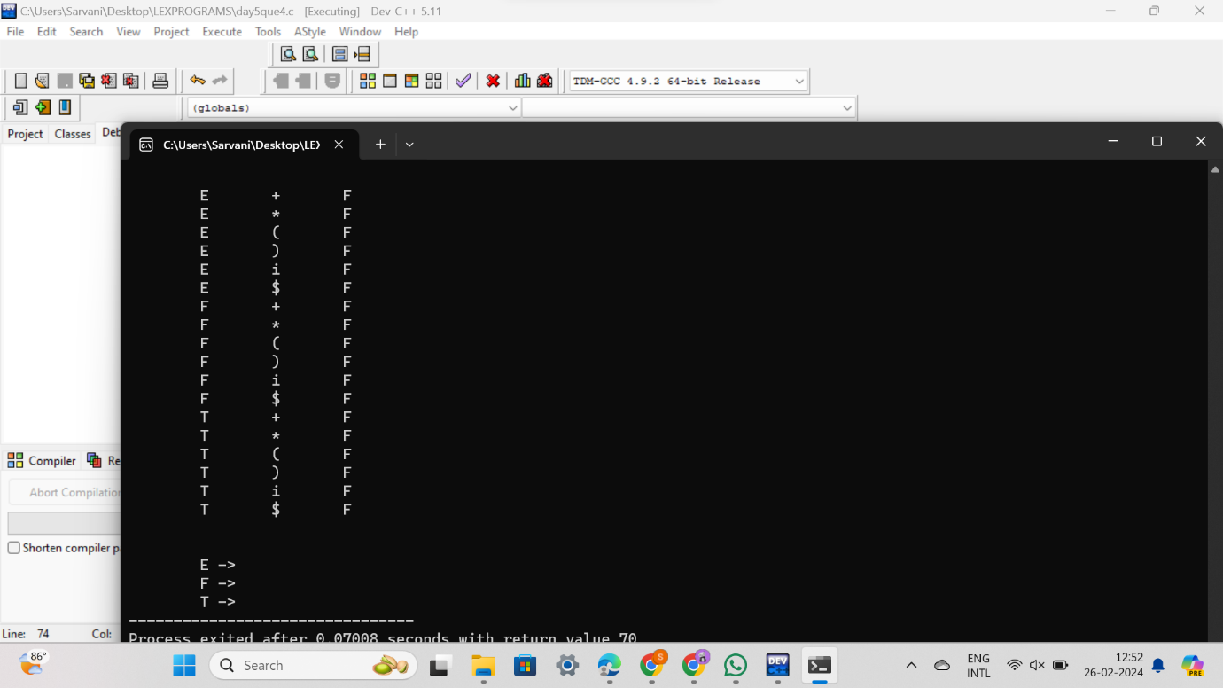

#include<conio.h>

#include<stdio.h>

char arr[18][3] ={{'E', '+', 'F'}, {'E', '*', 'F'}, {'E', '(', 'F'}, {'E', ')', 'F'}, {'E', 'i', 'F'},

{'E', '$', 'F'}, {'F', '+', 'F'}, {'F', '*', 'F'}, {'F', '(', 'F'}, {'F', ')', 'F'}, {'F', 'i', 'F'},

{'F', '$', 'F'}, {'T', '+', 'F'}, {'T', '*', 'F'}, {'T', '(', 'F'}, {'T', ')', 'F'}, {'T', 'i', 'F'},

{'T', '$', 'F'},

};

char prod[6] = "EETTFF";

char res[6][3] ={ {'E', '+', 'T'}, {'T', '\0', '\0'}, {'T', '*', 'F'}, {'F', '\0', '\0'}, {'(', 'E', ')'}, {'i', '\0', '\0'},};

char stack [5][2];

int top = -1;

void install(char pro, char re) {

int i;

for (i = 0; i < 18; ++i) {

if (arr[i][0] == pro && arr[i][1] == re) {

}

}

++top;

arr[i][2] = 'T';

stack[top][0] = pro;

stack[top][1] = re;

}

int main() {

int i = 0, j;

char pro, re, pri = ' ';

for (i = 0; i < 6; ++i) {

for (j = 2; j >= 0; --j) {

if (res[i][j] == '+' || res[i][j] == '*' || res[i][j] == '(' || res[i][j] == ')' || res[i][j] == 'i' || res[i][j] == '$') {

install(prod[i], res[i][j]);

break;

} else if (res[i][j] == 'E' || res[i][j] == 'F' || res[i][j] == 'T') {

if (res[i][j - 1] == '+' || res[i][j - 1] == '*' || res[i][j - 1] == '(' || res[i][j -

1] == ')' || res[i][j - 1] == 'i' || res[i][j - 1] == '$') {

install(prod[i], res[i][j - 1]);

break;

}

}

}

}

while (top >= 0) {

pro = stack[top][0];

re = stack[top][1];

--top;

for (i = 0; i < 6; ++i) {

for (j = 2; j >= 0; --j) {

if (res[i][0] == pro && res[i][0] != prod[i]) {

install(prod[i], re);

break;

} else if (res[i][0] != '\0') break;

}

}

}

for (i = 0; i < 18; ++i) {

printf("\n\t");

for (j = 0; j < 3; ++j)

printf("%c\t", arr[i][j]);

}

printf("\n\n");

for (i = 0; i < 18; ++i) {

if (pri != arr[i][0]) {

pri = arr[i][0];

printf("\n\t%c -> ", pri);

}

if (arr[i][2] == 'T')

printf("%c ", arr[i][1]);}

}

QUE 3

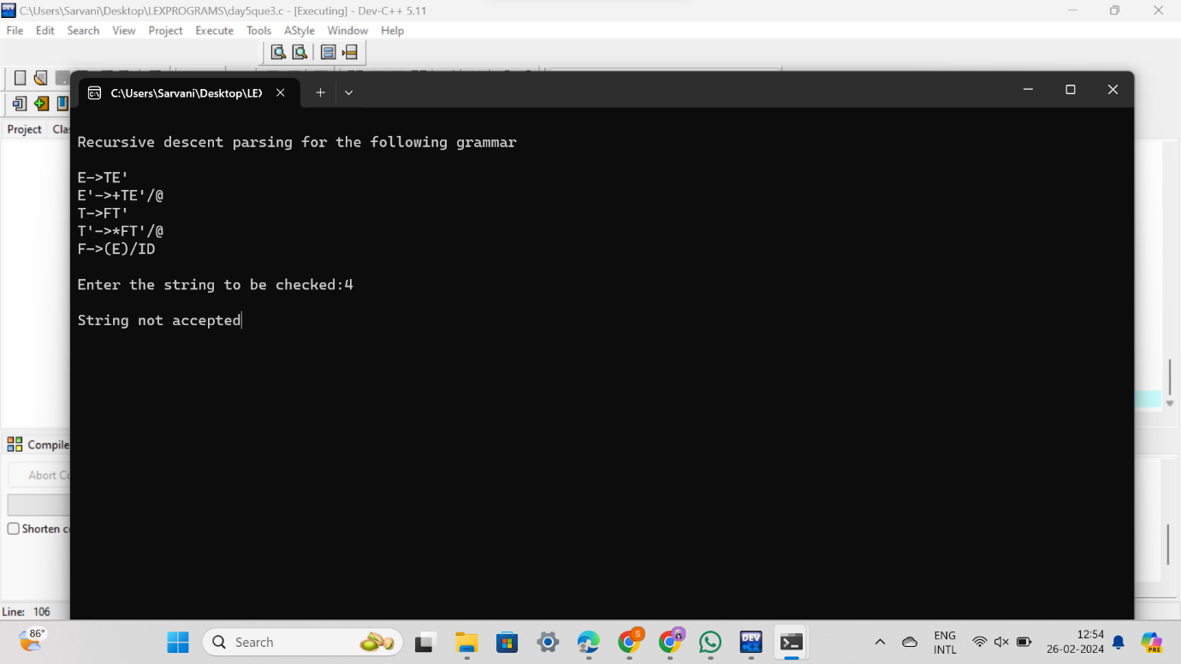

#include<stdio.h>

#include<conio.h>

#include<string.h>

char input[100];

int i,l;

void main()

{

//clrscr();

printf("\nRecursive descent parsing for the following grammar\n"); printf("\nE->TE'\nE'->+TE'/@\nT->FT'\nT'->*FT'/@\nF->(E)/ID\n"); printf("\nEnter the string to be checked:"); gets(input);

if(E())

{

if(input[i+1]=='\0')

printf("\nString is accepted");

else

printf("\nString is not accepted");

}

else

printf("\nString not accepted");

getch();

}

E()

{

if(T())

{

if(EP())

return(1);

else

return(0);

}

else

return(0);

}

EP()

{

if(input[i]=='+')

{

i++;

if(T())

{

if(EP())

return(1);

else

return(0);

}

else

return(0);

}

else

return(1);

}

T()

{

if(F())

{

if(TP())

return(1);

else

return(0);

}

else

return(0);

}

TP()

{

if(input[i]=='*')

{

i++;

if(F())

{

if(TP())

return(1);

else

return(0);

}

else

return(0);

}

else

return(1);

}

F()

{

if(input[i]=='(')

{

i++;

if(E())

{

if(input[i]==')')

{

i++;

return(1);

}

else

return(0);

}

else

return(0);

}

else if(input[i]>='a'&&input[i]<='z'||input[i]>='A'&&input[i]<='Z')

{

i++;

return(1);

}

else

return(0);

}

QUE 2

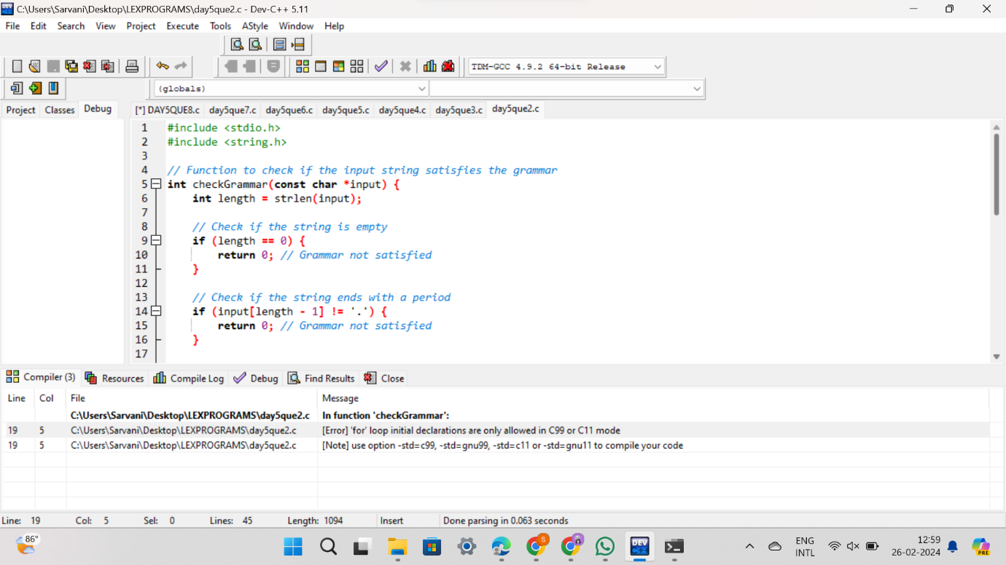

#include <stdio.h>

#include <string.h>

// Function to check if the input string satisfies the grammar

int checkGrammar(const char *input) {

int length = strlen(input);

// Check if the string is empty

if (length == 0) {

return 0; // Grammar not satisfied

}

// Check if the string ends with a period

if (input[length - 1] != '.') {

return 0; // Grammar not satisfied

}

// Check if the string has words separated by spaces

for (int i = 0; i < length - 1; i++) {

if (input[i] == ' ' && input[i + 1] == ' ') {

return 0; // Grammar not satisfied

}

}

return 1; // Grammar satisfied

}

int main() {

char input[100];

printf("Enter a sentence (ending with a period):\n");

fgets(input, sizeof(input), stdin);

// Remove the newline character from the input

input[strcspn(input, "\n")] = '\0';

if (checkGrammar(input)) {

printf("Grammar satisfied!\n");

} else {

printf("Grammar not satisfied!\n");

}

return 0;

}

QUE 1

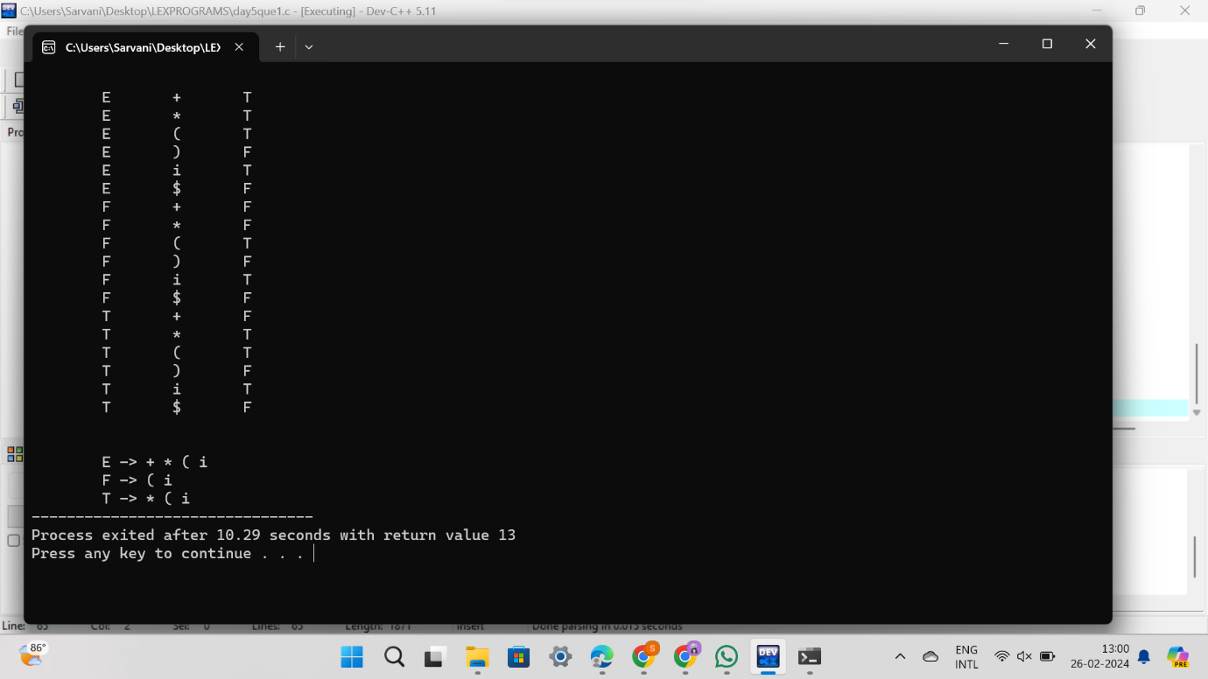

#include<conio.h>

#include<stdio.h>

char arr[18][3] ={{'E', '+', 'F'},{'E', '*', 'F'},{'E', '(', 'F'}, {'E', ')', 'F'},{'E', 'i', 'F'},{'E', '$', 'F'},

{'F', '+', 'F'},{'F', '*', 'F'},{'F', '(', 'F'},{'F', ')', 'F'},{'F', 'i', 'F'},{'F', '$', 'F'}, {'T', '+', 'F'},

{'T', '*', 'F'}, {'T', '(', 'F'},{'T', ')', 'F'},{'T', 'i', 'F'},{'T', '$', 'F'}};

char prod[] = "EETTFF";

char res[6][3] ={ {'E', '+', 'T'}, {'T', '\0'}, {'T', '*', 'F'}, {'F', '\0'}, {'(', 'E', ')'}, {'i', '\0'}};

char stack [5][2];

int top = -1;

void install(char pro, char re) {

int i;

for (i = 0; i < 18; ++i) {

if (arr[i][0] == pro && arr[i][1] == re) {

arr[i][2] = 'T';

break;

}

}

++top;

stack[top][0] = pro;

stack[top][1] = re;

}

int main() {

int i = 0, j;

char pro, re, pri = ' ';

for (i = 0; i < 6; ++i) {

for (j = 0; j < 3 && res[i][j] != '\0'; ++j) {

if (res[i][j] == '+' || res[i][j] == '*' || res[i][j] == '(' || res[i][j] == ')' || res[i][j] == 'i' || res[i][j] == '$') {

install(prod[i], res[i][j]);

break;

}

}

}

while (top >= 0) {

pro = stack[top][0];

re = stack[top][1];

--top;

for (i = 0; i < 6; ++i) {

if (res[i][0] == pro && res[i][0] != prod[i]) {

install(prod[i], re);

}

}

}

for (i = 0; i < 18; ++i) {

printf("\n\t");

for (j = 0; j < 3; ++j)

printf("%c\t", arr[i][j]);

}

getch();

printf("\n\n");

for (i = 0; i < 18; ++i) {

if (pri != arr[i][0]) {

pri = arr[i][0];

printf("\n\t%c -> ", pri);

}

if (arr[i][2] == 'T')

printf("%c ", arr[i][1]);

}

getch();

}